**Phase 5**

**Lesson 3**

**Create an IAM Role**

**Steps:**

1. Creating an IAM role

2. Adding AWS policy to the role

3. Providing a key and a value for the role

**Step 1:** Creating an IAM role

* In the IAM panel, click on *Roles* -> *Create role*

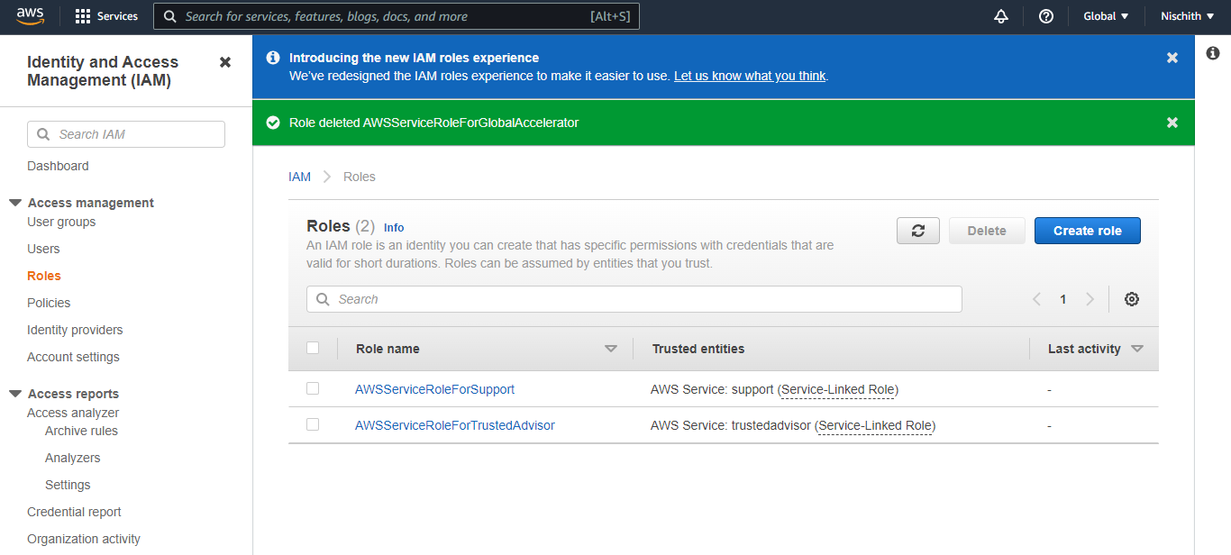

* Select the service

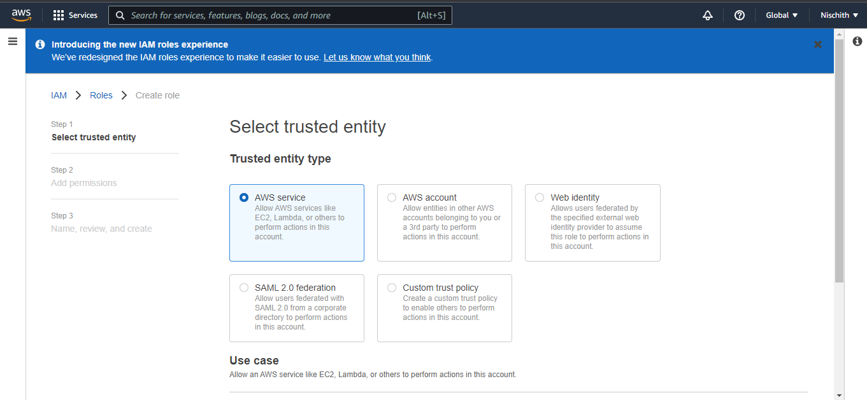

**Step 2:** Adding AWS policy to the role

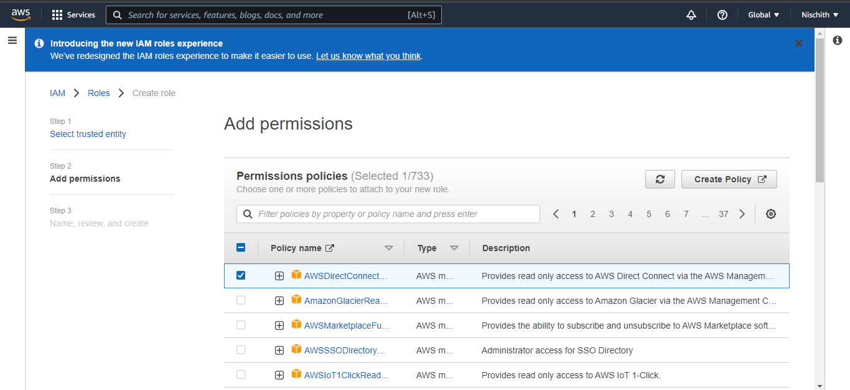

**Step 3:** Providing a key and a value for the role

* Add role

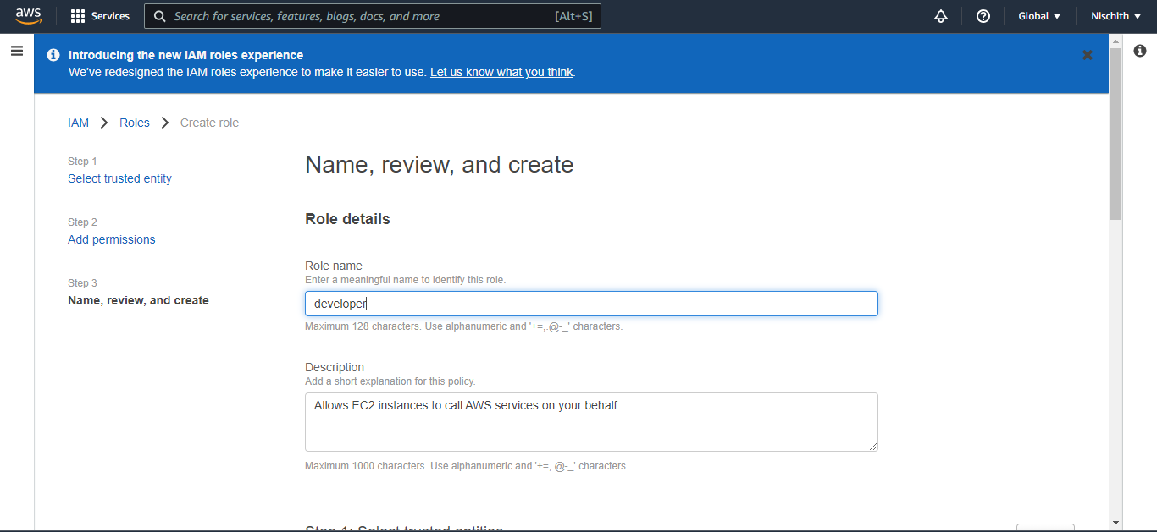

* Once the role is created, you can find it in the IAM panel

